**Project : Display Bookshelves**

**Cohort - QEA20QE032**

**Group 7 (The Optimizers)**

**Project Module**

1. Display the name & price of first 3 Bookshelves below Rs.15000, with Storage type as open & exclude out of stock.

2. Take first 3 study chair details with highest recommendation.

3. From Collections, retrieve all sub-menu items under Being-At-home and store in a List; Display the same.

4. Gift cards - choose "Birthday/Anniversary"; fill customize the gift card; fill from to details with any one input invalid (example: email); Capture & display the error message.

# **Prerequisites**

Steps to automate:

* Initially we need to launch the **Urbanladder** Website.
* There is a wait time of 10000seconds given in our automation project.
* However we can change the wait time according to the user satisfaction.

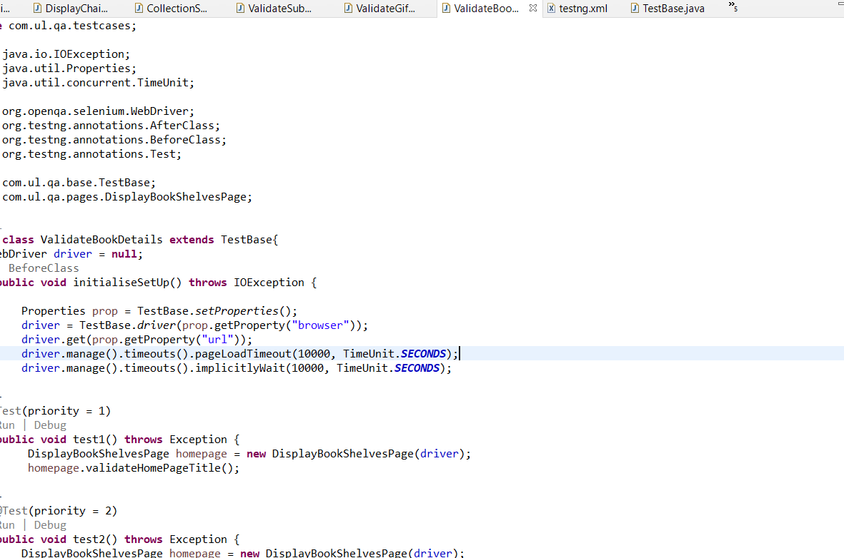

We have written all the input values in the excel sheet under **Resource Folder**.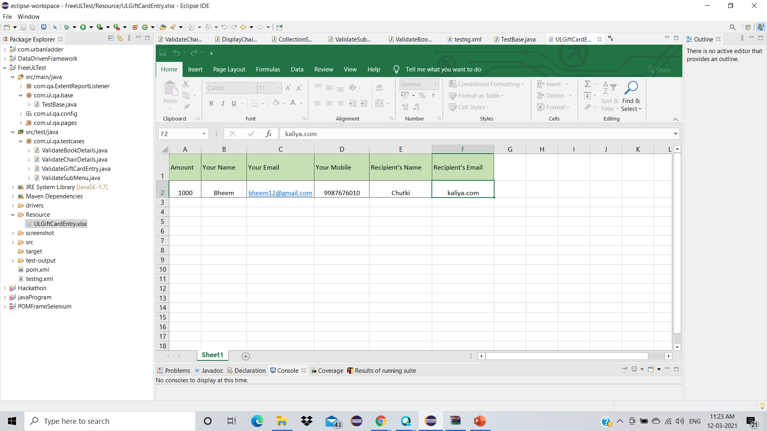

* We captured the error message for invalid email entry.

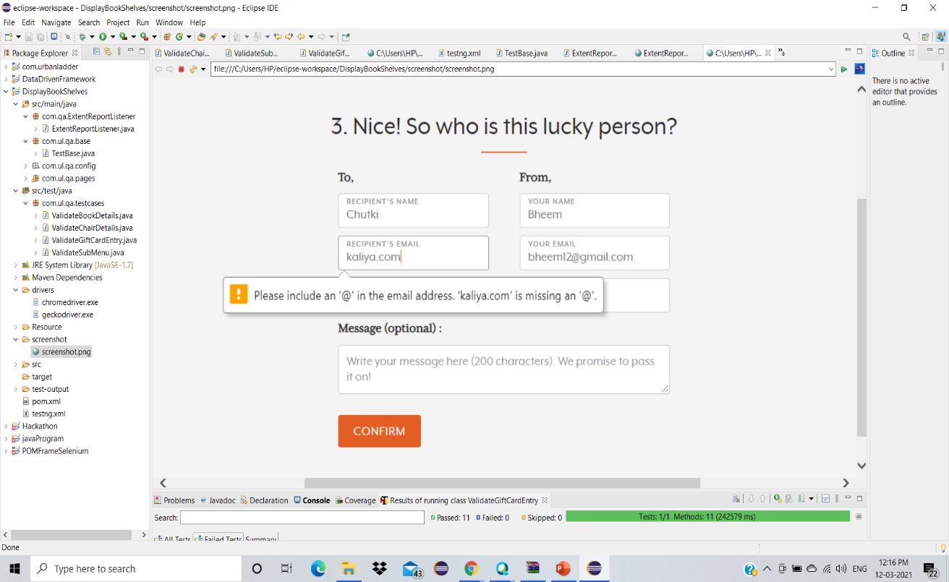

* HTML Report

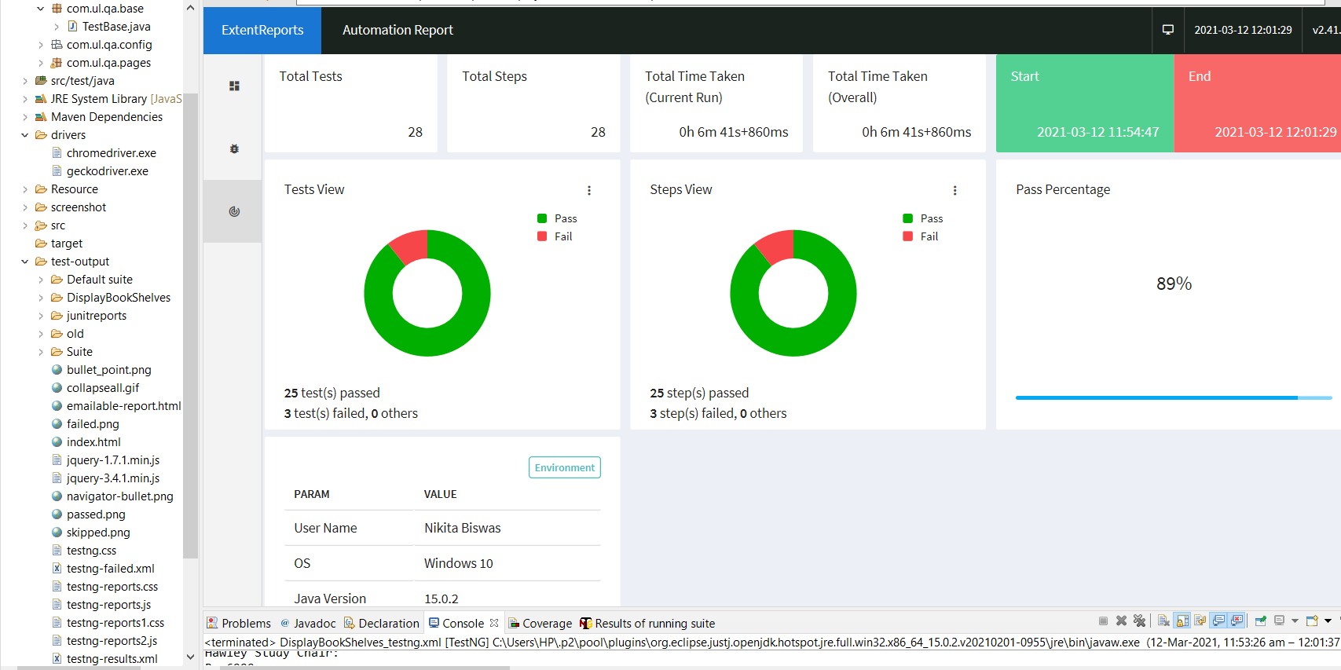

**Once everything is setup:**

* Right click on the testing.xml🡪Run As🡪1TestNG Suite

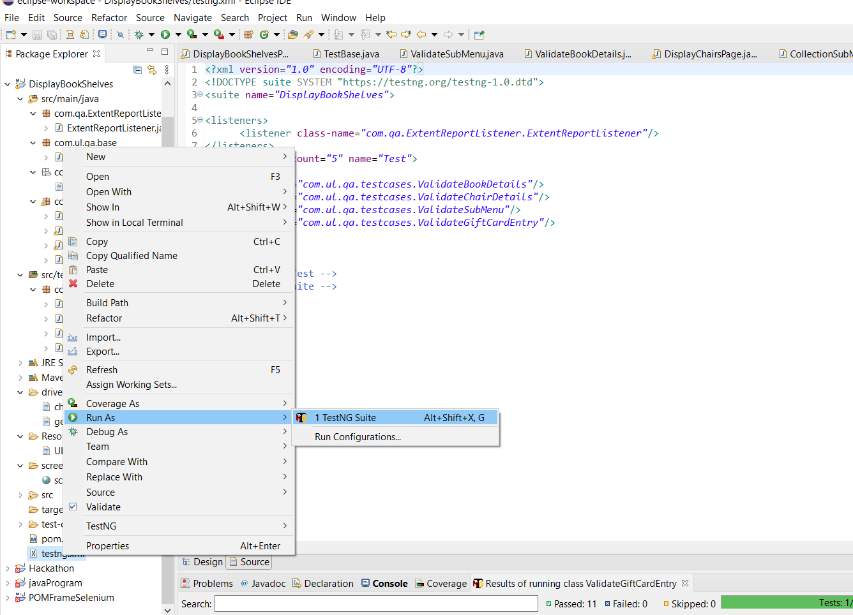

* We are navigated to the Urbanladder Website. **https://www.urbanladder.com/**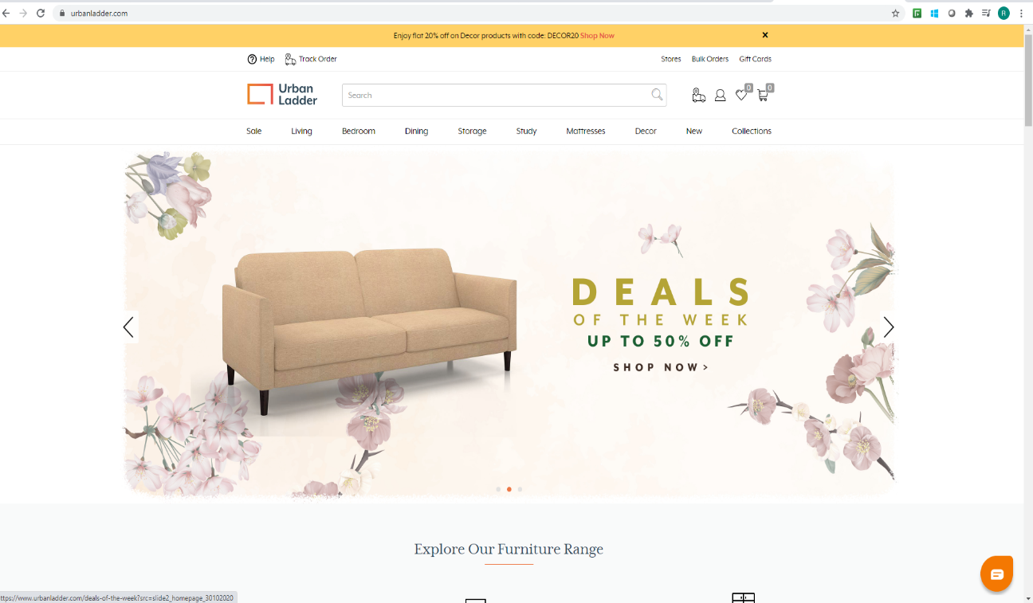
* We have to wait for the popup to appear and then close the popup.

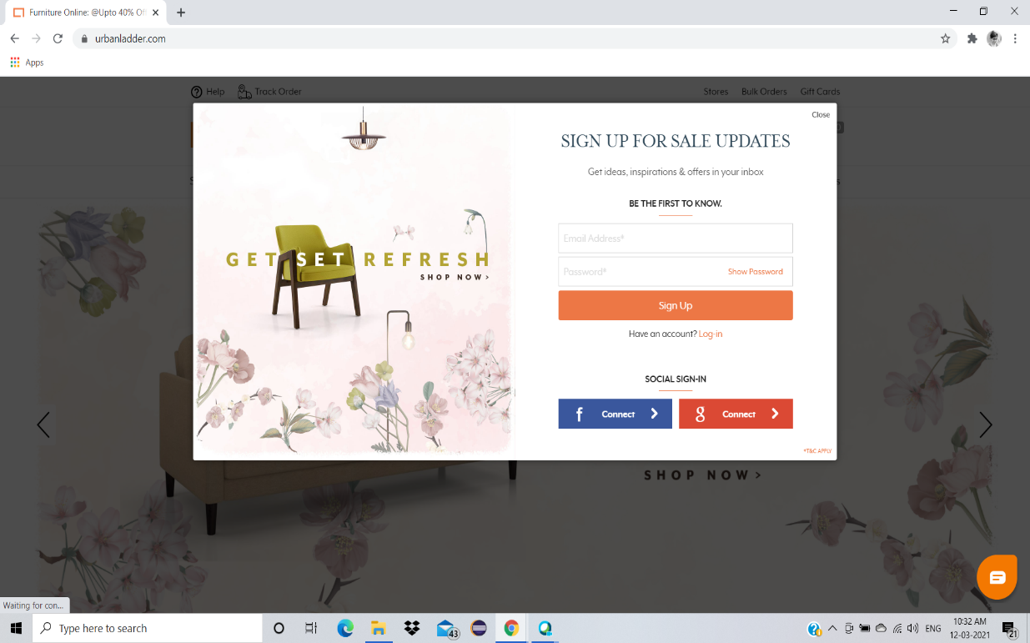

* In the search box we have to search for Bookshelves.

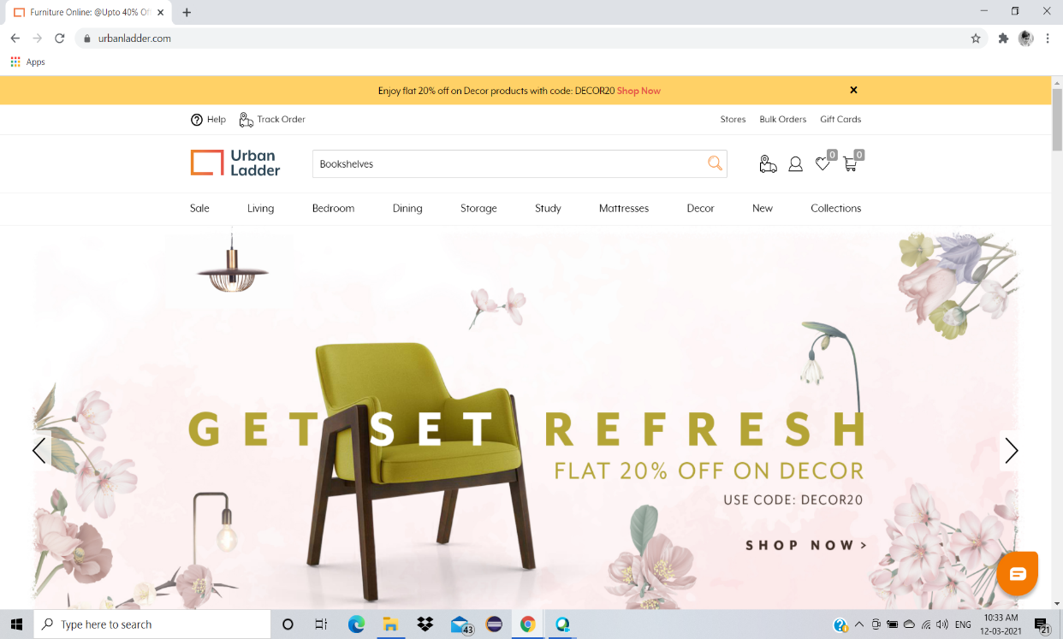

* From category dropdown box we have to select Bookshelves.

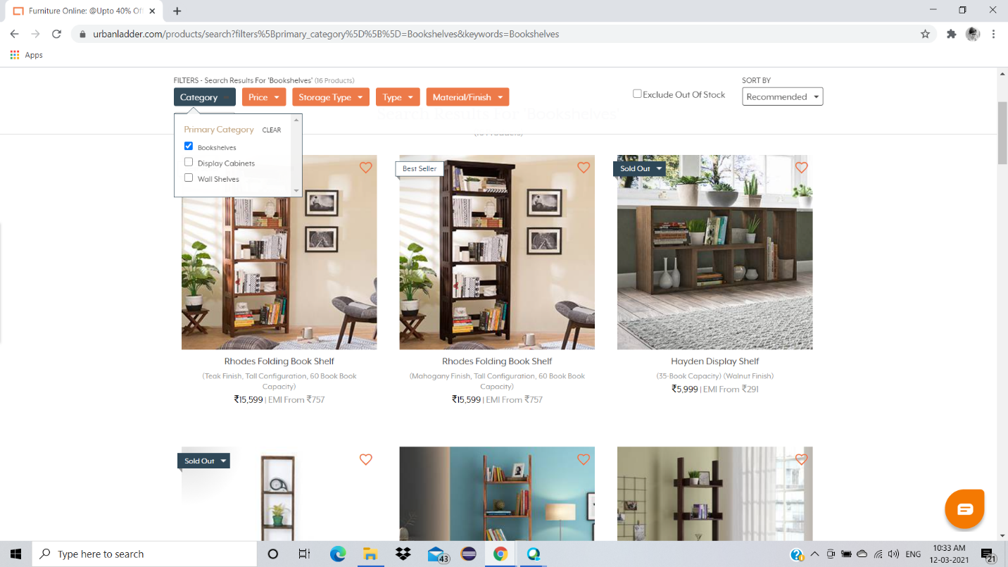

* We have to select the open from the Dropdown Box.

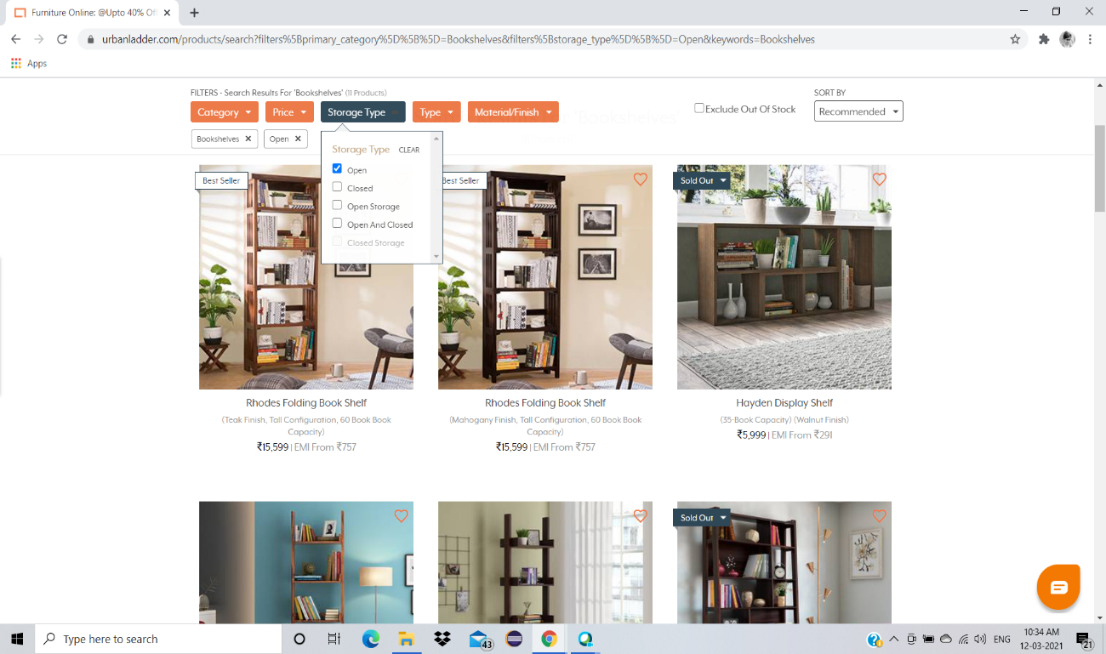

* We have to check on the Exclude out Of Stock Checkbox.

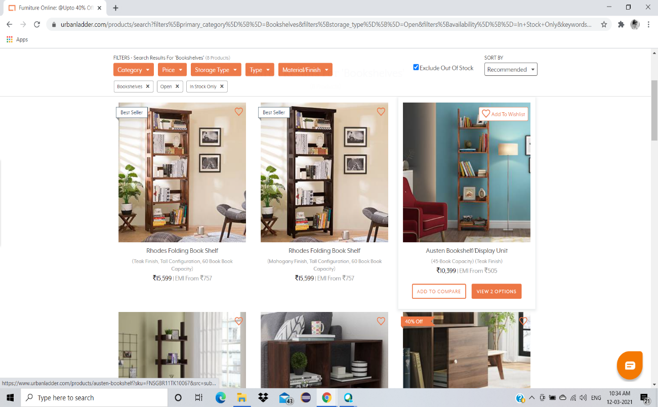

* We have to select the recommendation as Price: low to high.

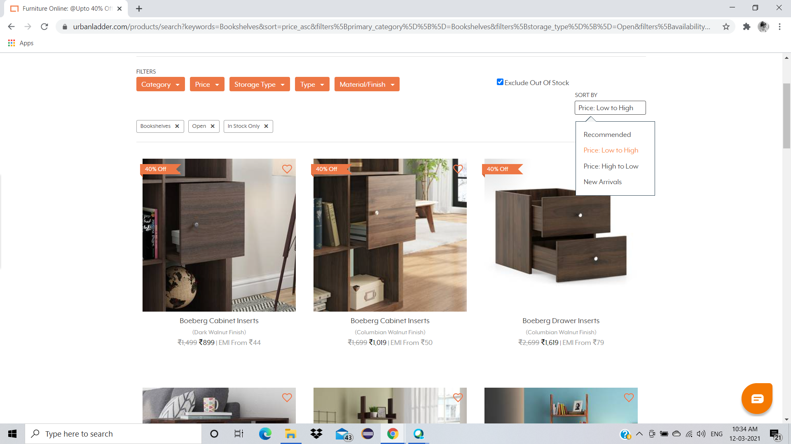

* We have to retrieve the top three name and price of the Bookshelves.

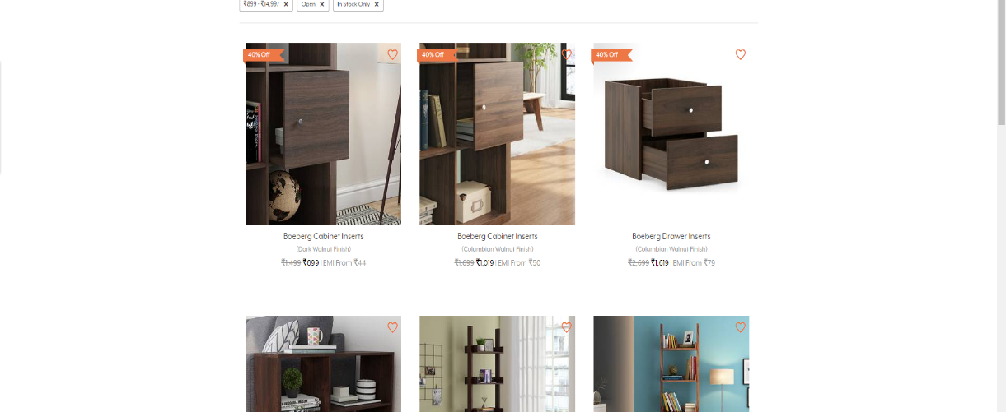

* Then we have to search for Study chair.

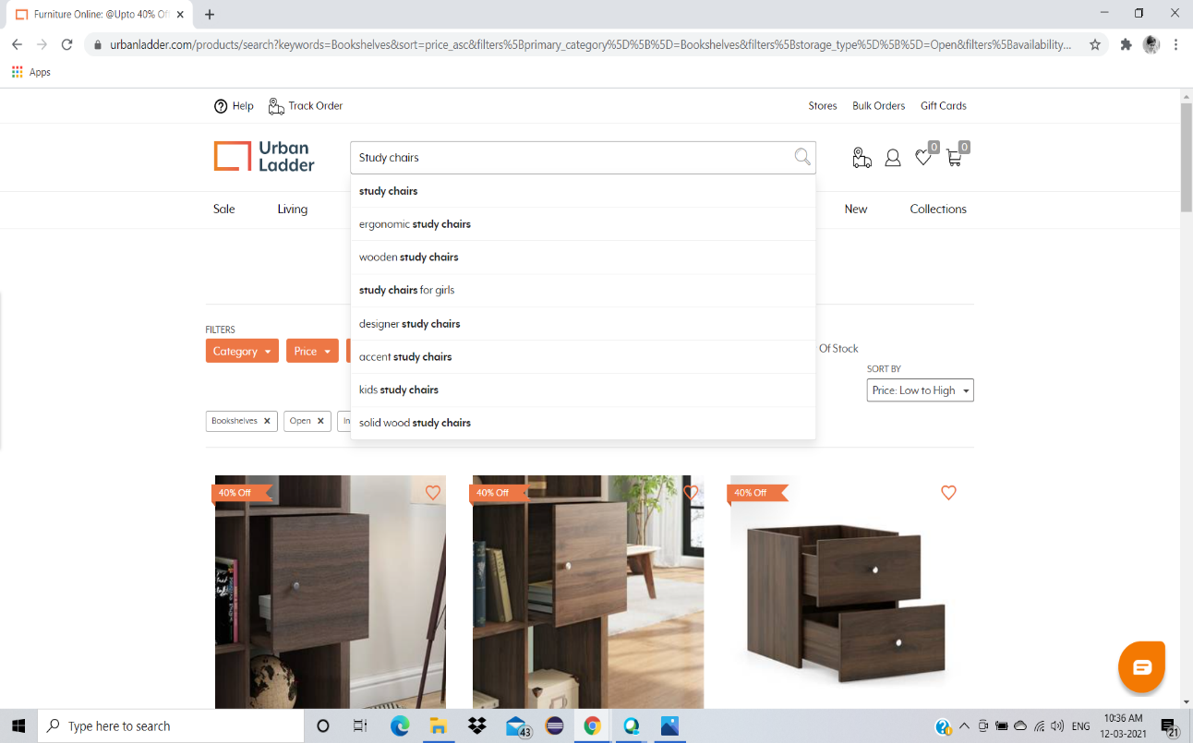

* We have to retrieve the first three Study chair details.

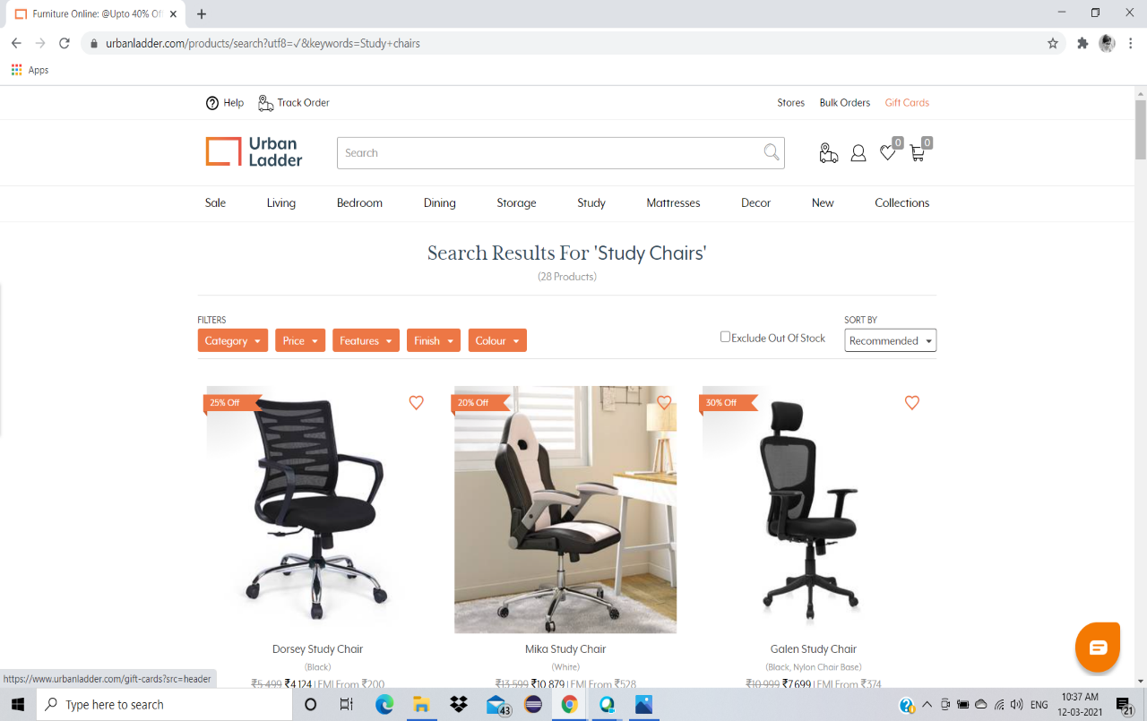

* We have to click on collections menu and retrieve all the items under Being At Home submenu.

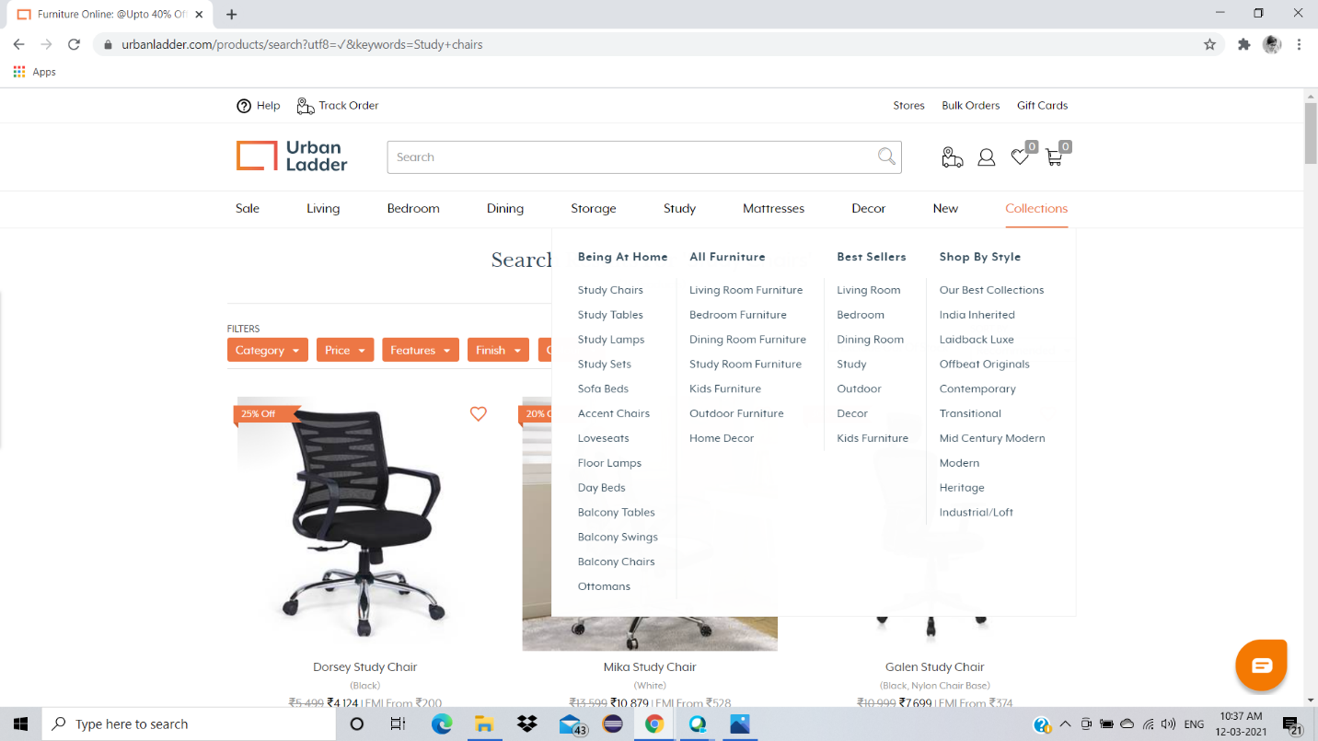

* We have to click on Gift Cards menu.

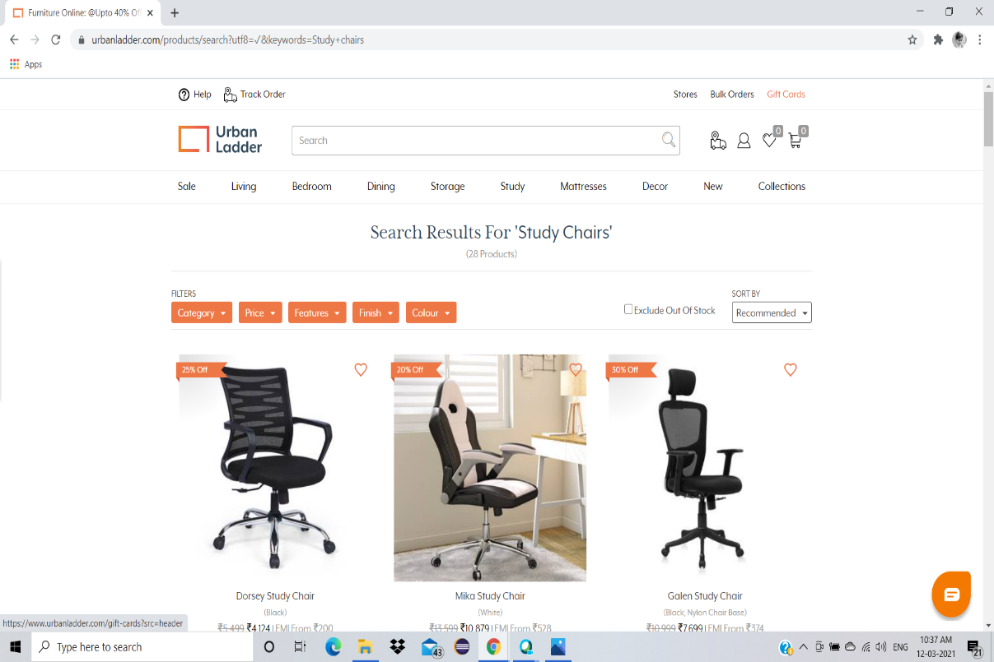

* We have to click on Birthday/Anniversary

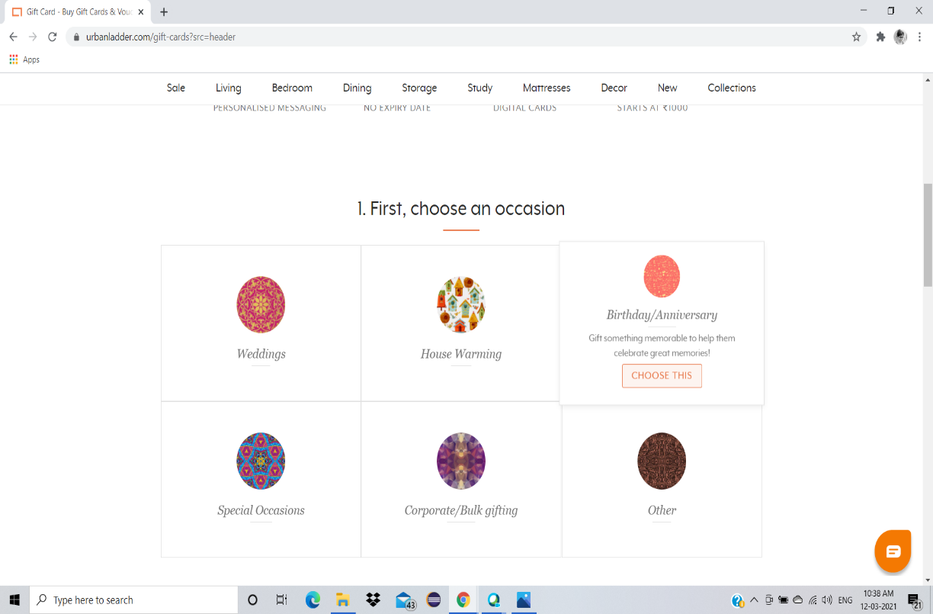

* We have to customize the gift card, enter the amount in the textbox and click on next button.

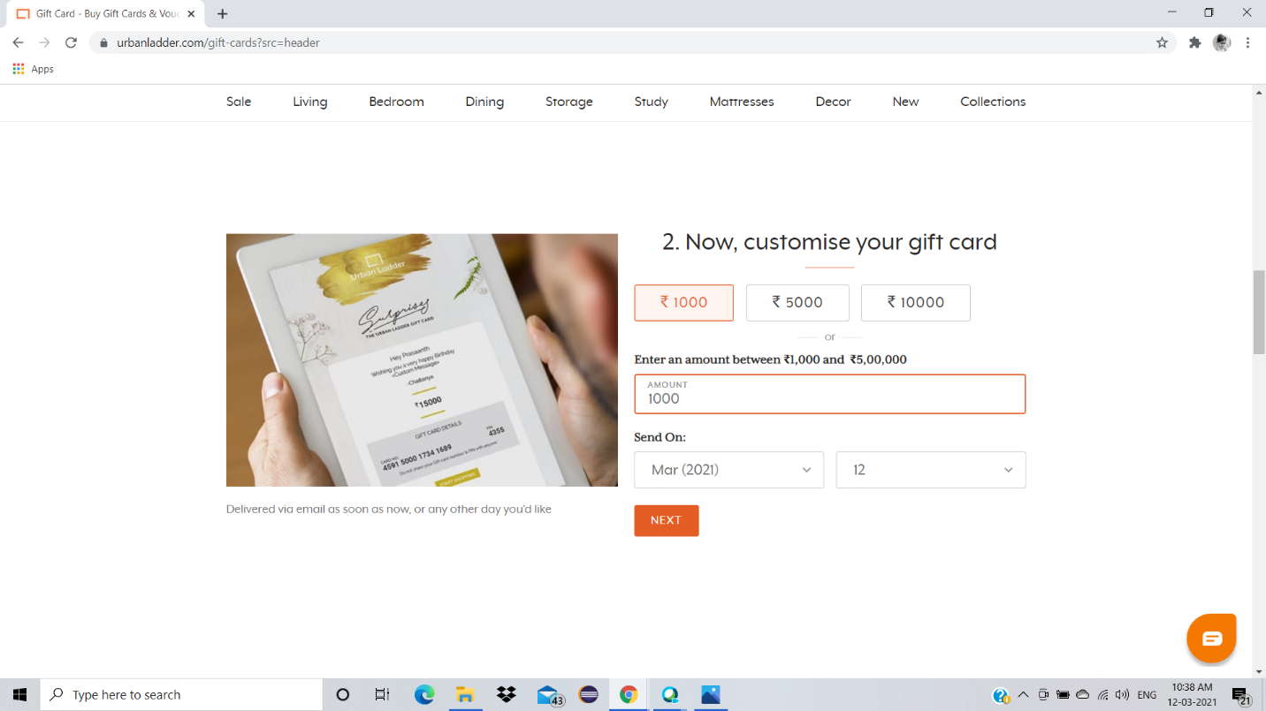

* We have to fill the from with one input as invalid (ex: Email) and capture the error message displayed.

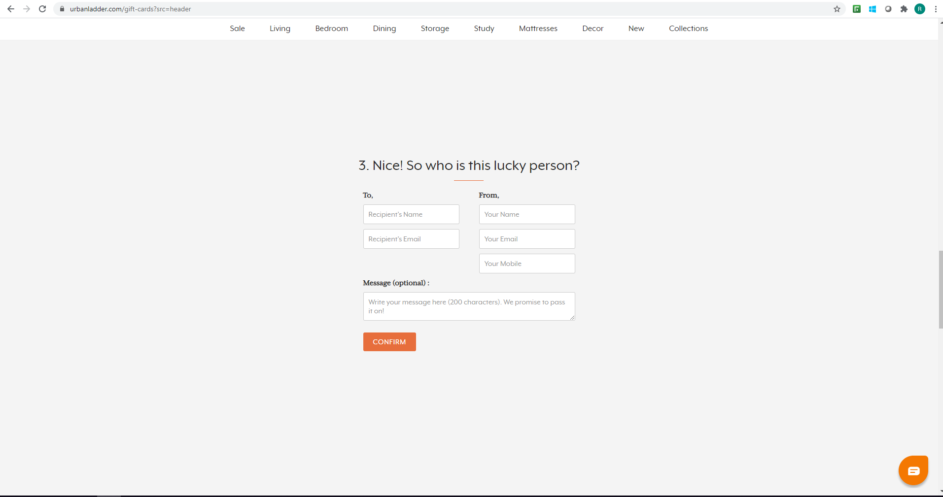

# What contains in

# (Script details)

# The project follows maven standards with a hybrid framework i.e.,

# The mixture of Data-driven and POM.

2. There are 2 source files - "src/main/java" and "src/test/java".

3.“src/main/java” consists of 4 Packages- com.qa.ExtentReportListener, com.ul.qa.base, com.ul.qa.pages, com.ul.qa.testcases.

4.“src/test/java” consists of only 1 package- com.ul.qa.testcases.

5. Drivers are kept under the “drivers” folder.

6. Excel sheet is kept under the “Resource” folder.

7. “Screenshot” folder contains the Screenshot of the error message.

8. “Documentation” folder contains all the documentations related to the project.

